**Military project (Sykhiv Gang-1)**

The goal of the project is to provide an easy and convenient way to manage military storage and register brigades for receiving equipment. The system allows to create brigades or join one of them, simplifies the way of managing provided items.

**Roles:**

| Role | Description |
| --- | --- |
| Commander | Register in a system, log in/log out, create brigade, view  statistics about soldiers, their ammunition, weapon, equipment and other. Write changes about amount of items that currently are in storages and in use by soldiers. |
| Soldier | Register in a system, log in/log out, view a list of soldiers who registered in his brigade, view statistics about his own brigade, create a request for more items if needs to |
| Admin | Can view info about users, brigades and statistics. Can manage everything. |
| Volunteer | Can pick one of brigades for delivering them needed items. Can filter brigades by city, name or by percentage of lacking items. |

**Brigade Management System**

| **№** | Role | Use case | Description | Action name | Tests |
| --- | --- | --- | --- | --- | --- |
| **1** | Commander | Add weapon/ammunition | Add needed weapon/ammunition with all necessary information. |  |  |
| **2** | Edit weapon/ammunition | Edit any information about weapon/ammunition (count, price…) |  |  |
| **3** | Delete weapon/ammunition | Delete a weapon/ammunition from the needed list |  |  |
| **4** | View soldiers | View the list of soldiers who registered in the same brigade. |  |  |
| **5** | Register soldiers | Register new soldiers to the brigade |  |  |
| **6** | Delete soldiers | Delete soldiers to the brigade |  |  |
| **7** | Edit brigade | Edit information about the brigade |  |  |
| **8** | View requests | View soldiers requests about changing info of weapons/ammunitions |  |  |
| **9** | Manage requests | Approve/reject soldiers requests of changing info about weapons/ammunitions |  |  |
| **10** | Soldier | View stuff | View information about weapons/ammunition in the brigade |  |  |
| **11** | Send requests | Send requests to the commander to change information about weapons/ammunition |  |  |
| **12** | Volunteer | View brigades | View information about all brigade’s stuff |  |  |

**Delivering Request Management System**

| **№** | Role | Use case | Description | Action name |
| --- | --- | --- | --- | --- |
| **1** | Commandor | Send help requests | Send requests with all needed stuff to volunteer |  |
| **2** | View requests status | View status of each request that was sent to volunteer |  |
| **3** | Volunteer | View requests | View all sent requests |  |
| **4** | Approve requests | Approve requests and let commander know about it |  |
| **5** | View routes | View optimal routes for delivering stuff to certain brigade |  |

**Account Management System**

| **№** | Role | Use case | Description | Action name |
| --- | --- | --- | --- | --- |
| **1** | Guest | Sign up | Sign up in a system |  |
| **2** | Log in | Log in to a system |  |
| **3** | Manage account | Edit personal information, delete an account, change a password |  |
| **4** | Commander/soldier/volunteer | Log out | Log out of a system |  |
| **5** | Manage account | Edit personal information, delete an account, change a password |  |

**User Management System**

| **№** | Role | Use case | Description | Action name | Tests |
| --- | --- | --- | --- | --- | --- |
| **1** | Admin | Add user | Add new commander/soldier/volunteer to the system |  |  |
| **2** | View users | View the list of users |  |  |
| **3** | Manage user’s account | Edit personal information, delete an account, change a password. |  |  |

**Tests**

| **№** | Test class | Test method | Code coverage |
| --- | --- | --- | --- |
|  |  |  |  |

**Use case diagrams**

**Guest use case diagram:**

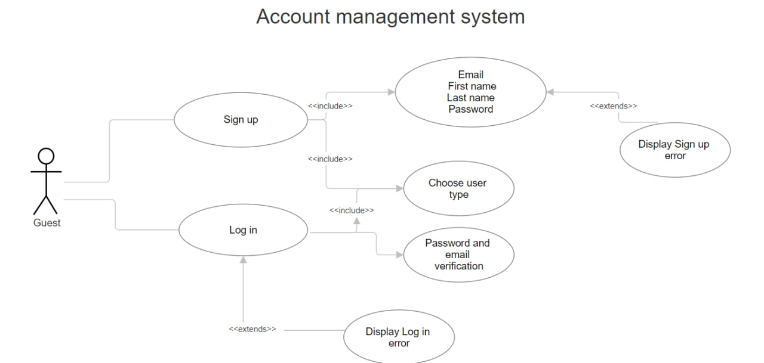

**Commander use case diagram:**

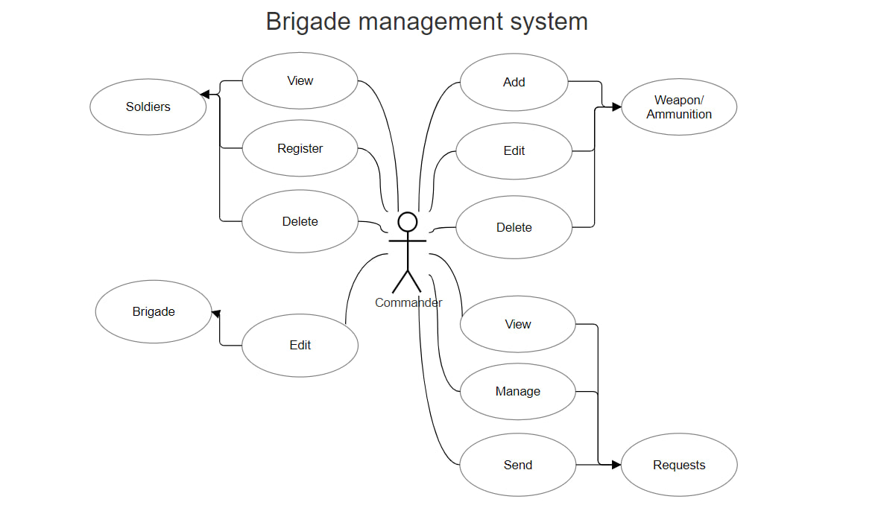

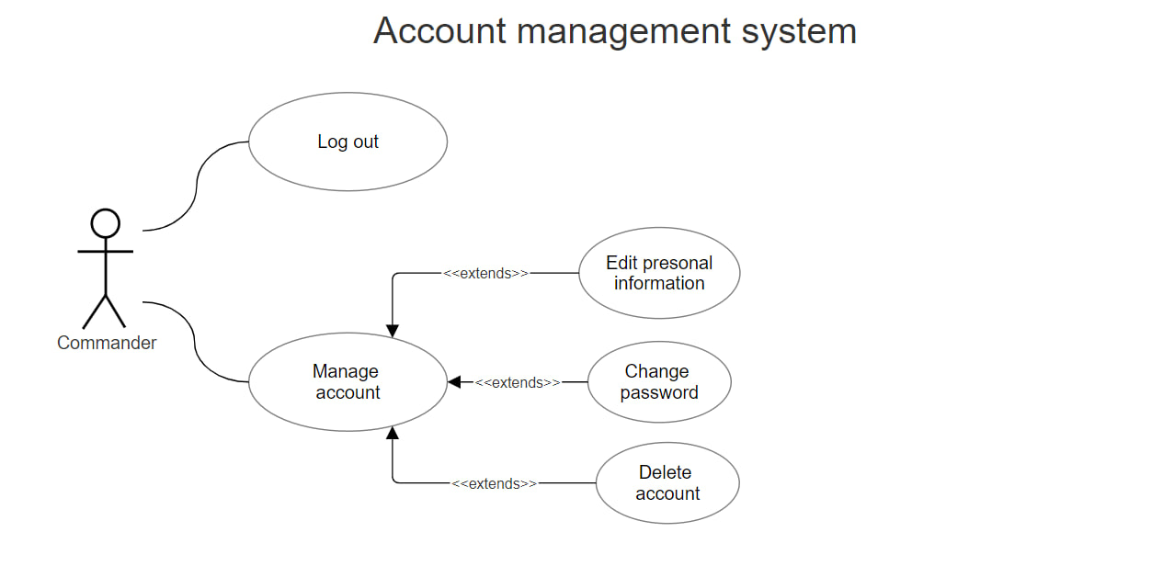

**Soldier use case diagram:**

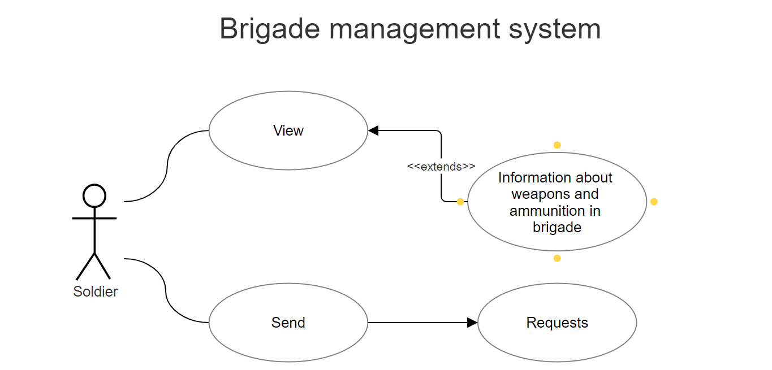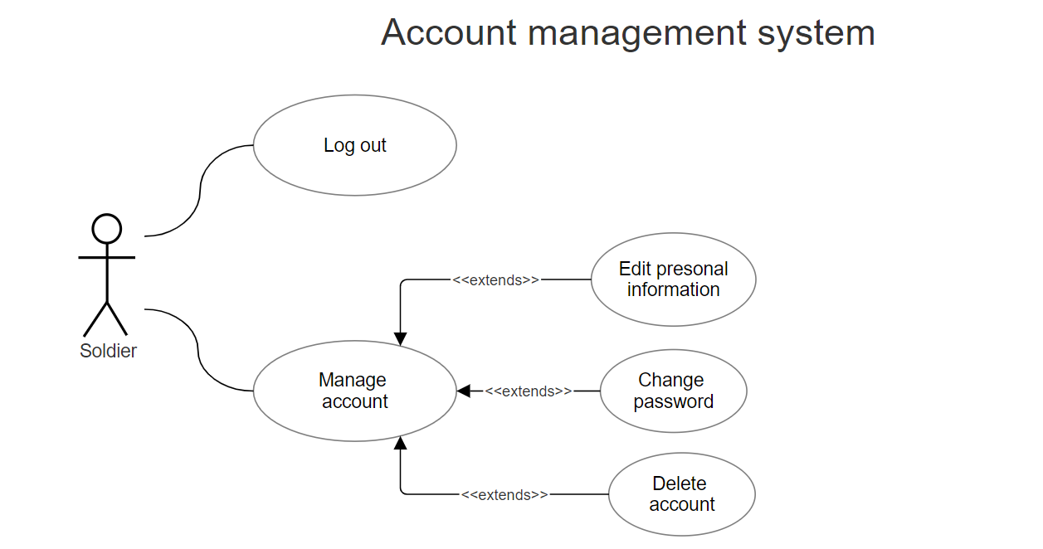

**Volunteer use case diagram:**

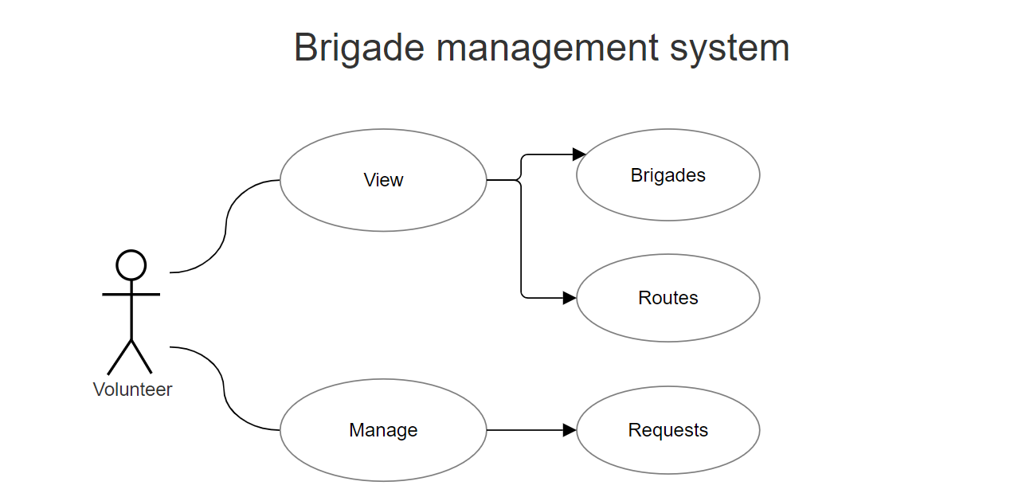

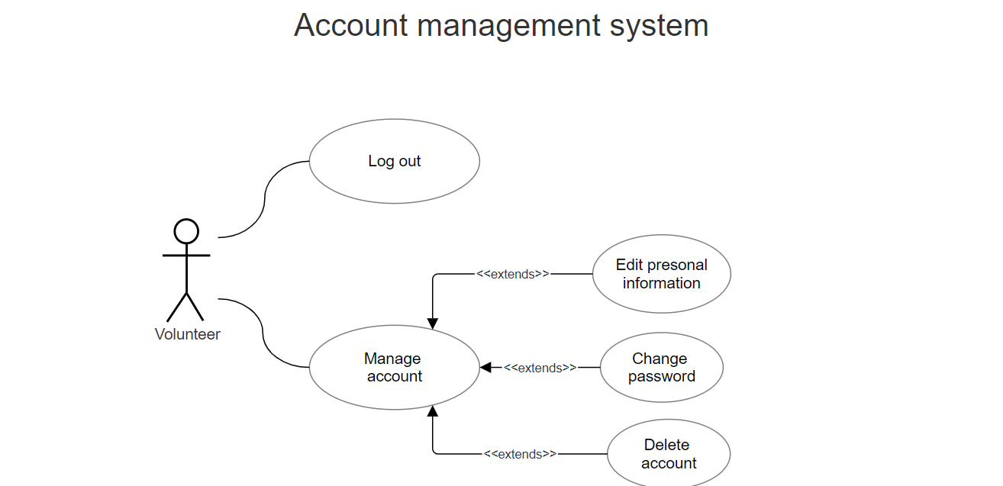

**Admin use case diagram:**

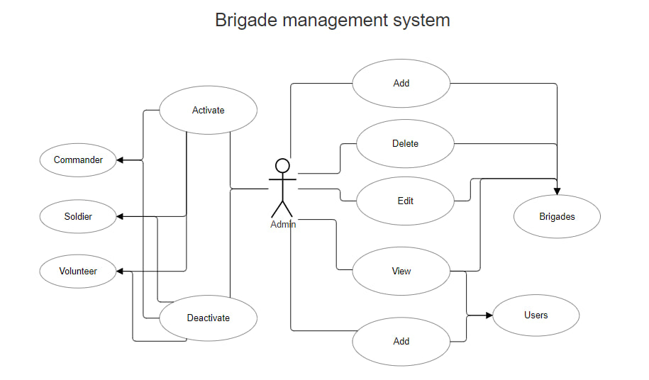

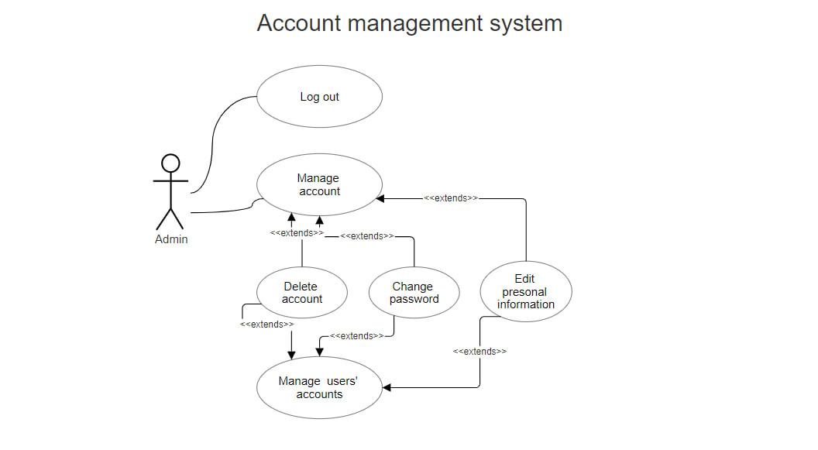

**Sequence diagram**

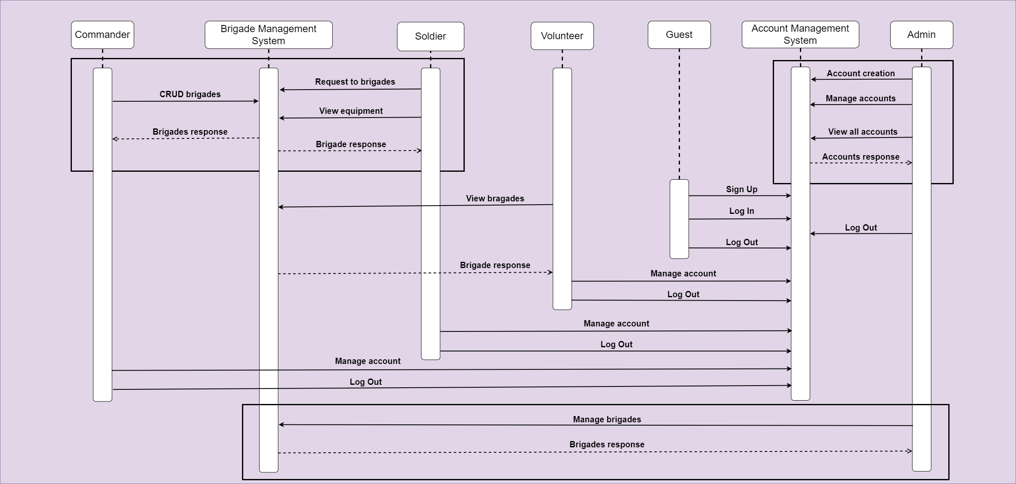

**ER-diagram**

**MOCKUPS**

Choose

Login

Create account

List of ammunition brigade is provided with

List of soldiers in brigade

List of weapon brigade is provided with

Adding new soldier to brigade

Adding new ammunition

